Link: <https://www.tripadvisor.com.tw/Restaurant_Review-g51817-d514956-Reviews-Local_Boyz_Hawaiian_Cafe-Corvallis_Oregon.html>

About: A lovely store provides very local Hawaiian food. The appealing smell always comes to people even though they don’t know where it comes from. Please come upstairs of the blue houses and grab some delicious grilled Hawaiian food.

Loco Moco – Menehune $8.25 Regular $10.5

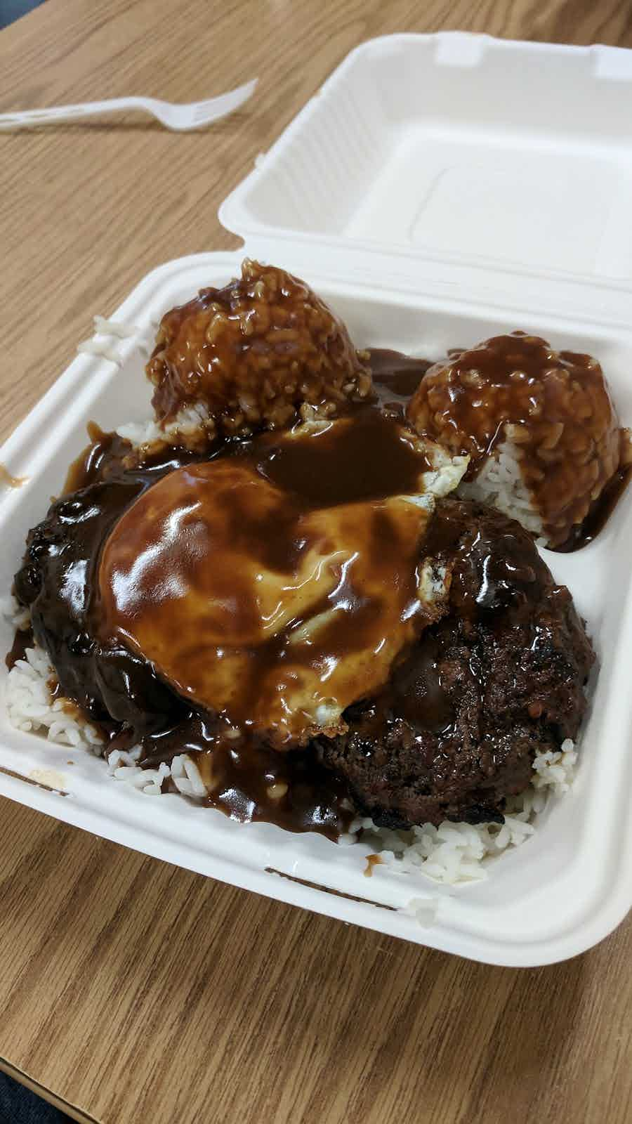

Hawallan Style Steak – Menehune $8.25 Regular $10.75

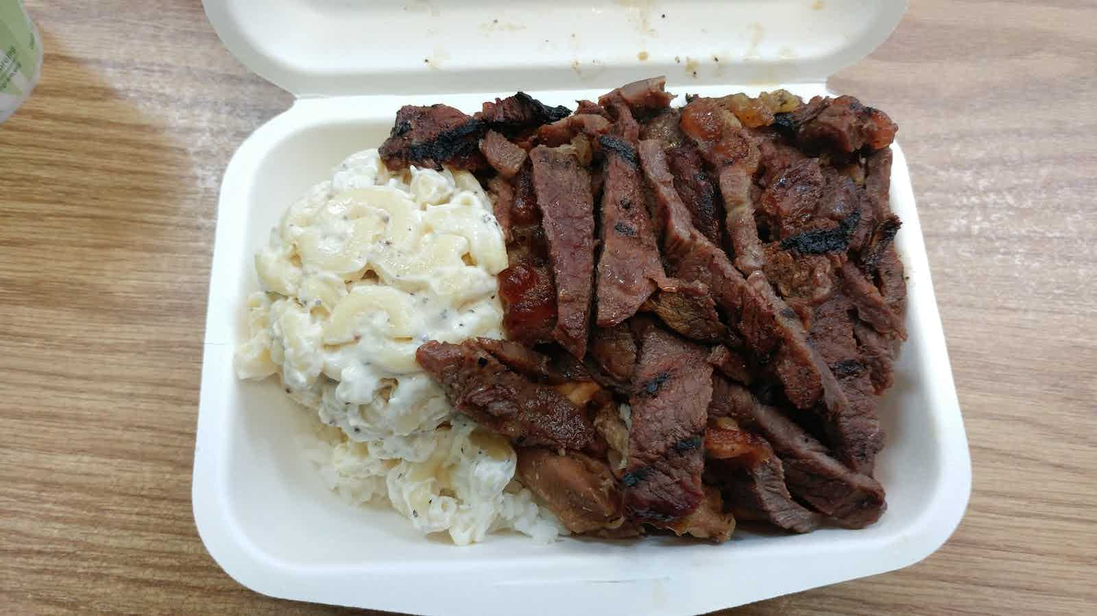

Sweet Shoyu Chicken– Menehune $7.50 Regular $10.00

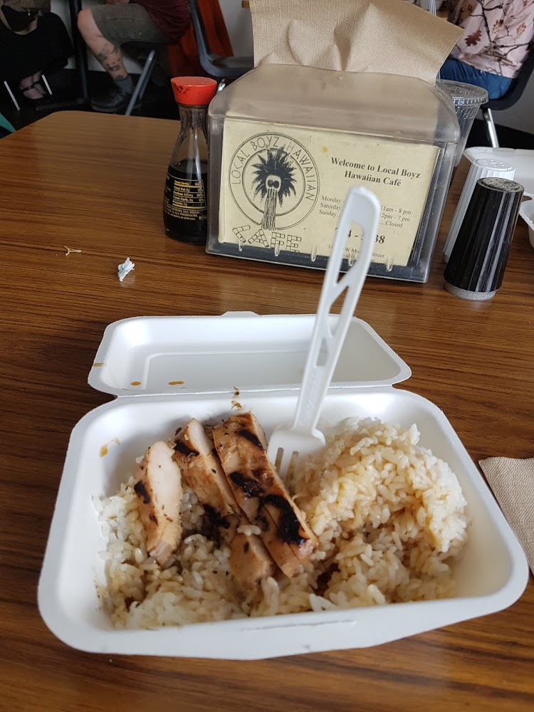

Mixed Plate – Menehune $8.75 Regular $12.0

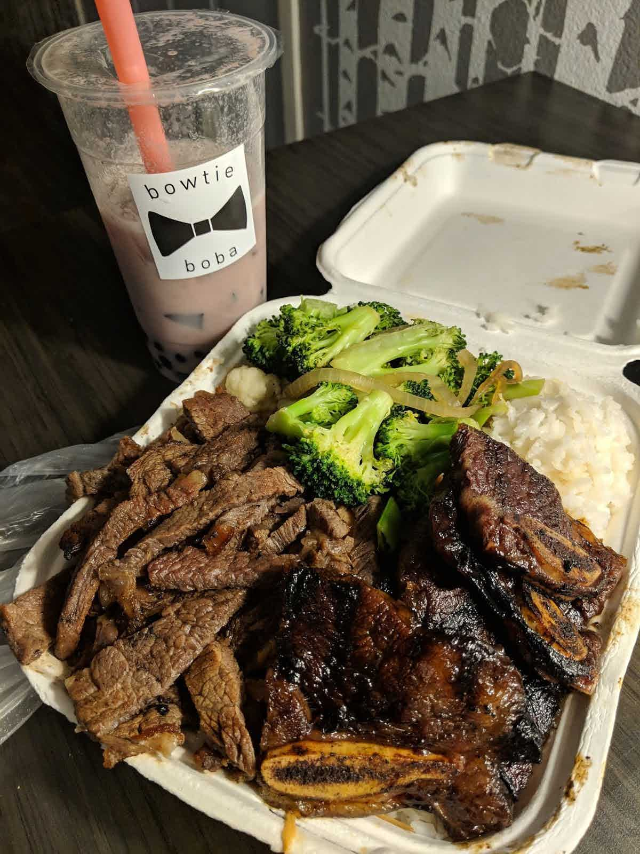

Sweet Shoyu Chicken or Hawallan Style Steak Stir Fry – Menehune $8.50 Regular $11

